**12/05/2025**

Task on IAM.  
##################

1. Create one IAM user and assign ec2,s3 full access role.

* Go to IAM---->users--->create user--->provide user name
* Tick check box and select I want to create an IAM user
* In Console password click on custom password
* Uncheck box
* Click next
* Select attach policies directly
* Search s3 and select Amazons3fullacess
* Click nect and scroll down select create user
* Successfully created IAM user
* We have url to sign to IAM account or you can sign directly with IMA user from Aws console

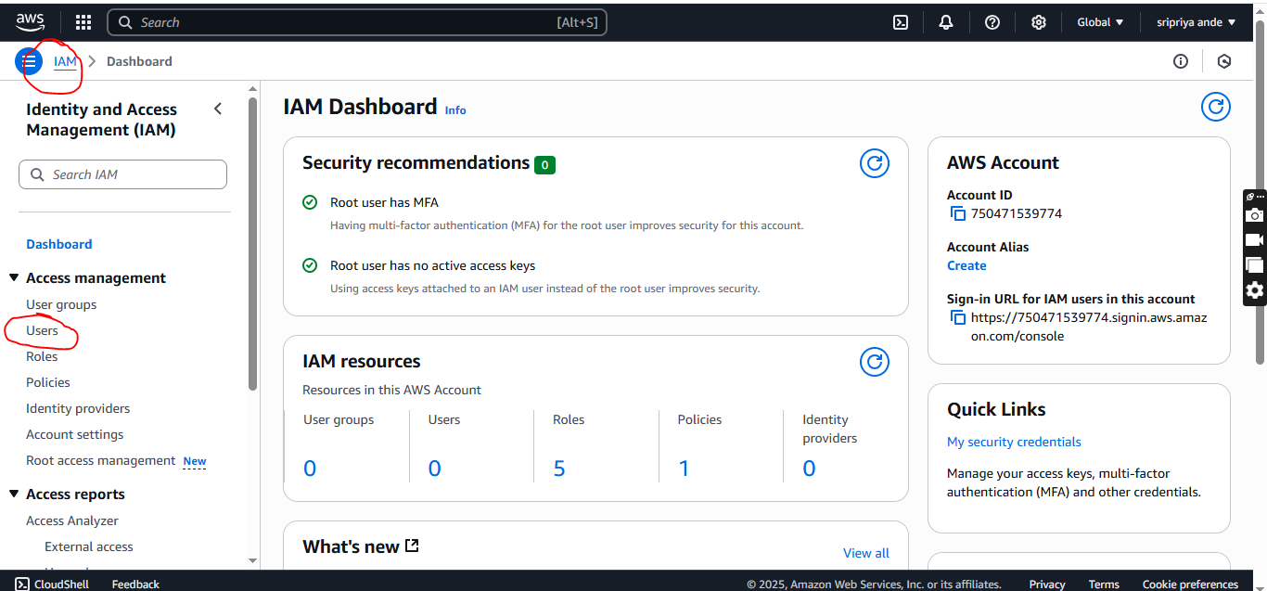

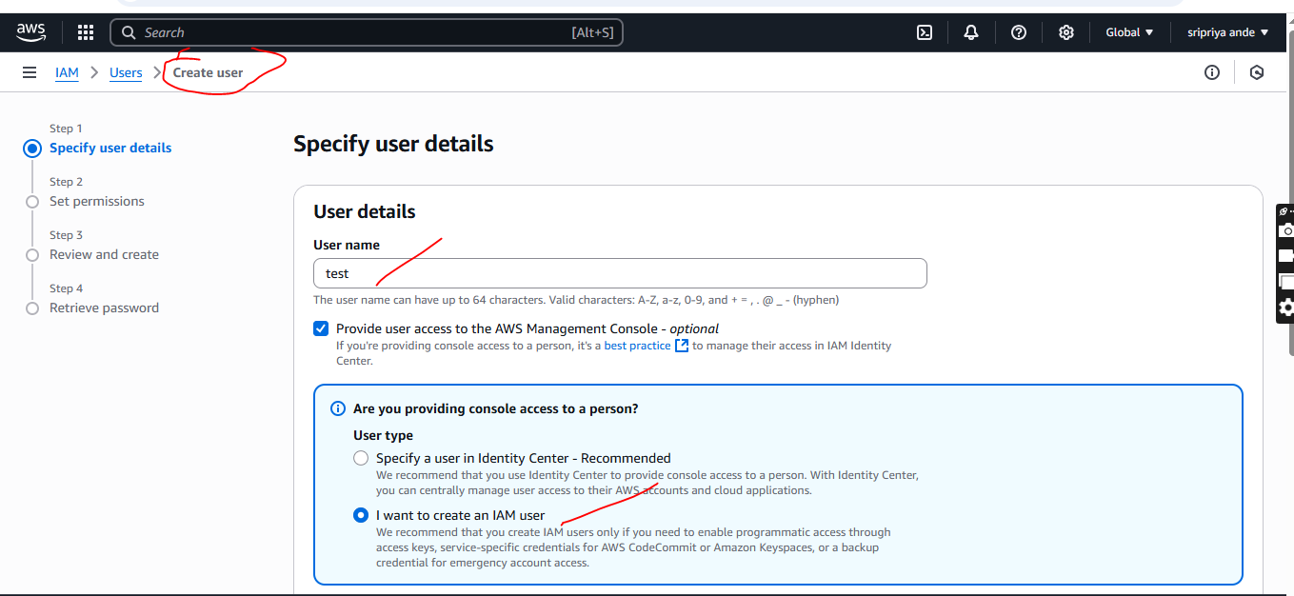

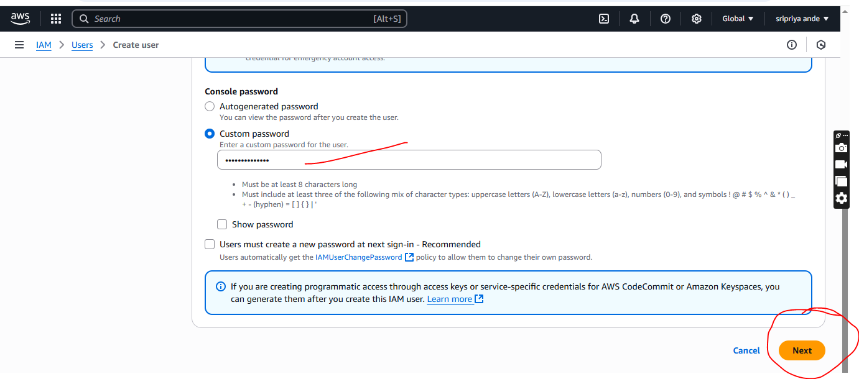

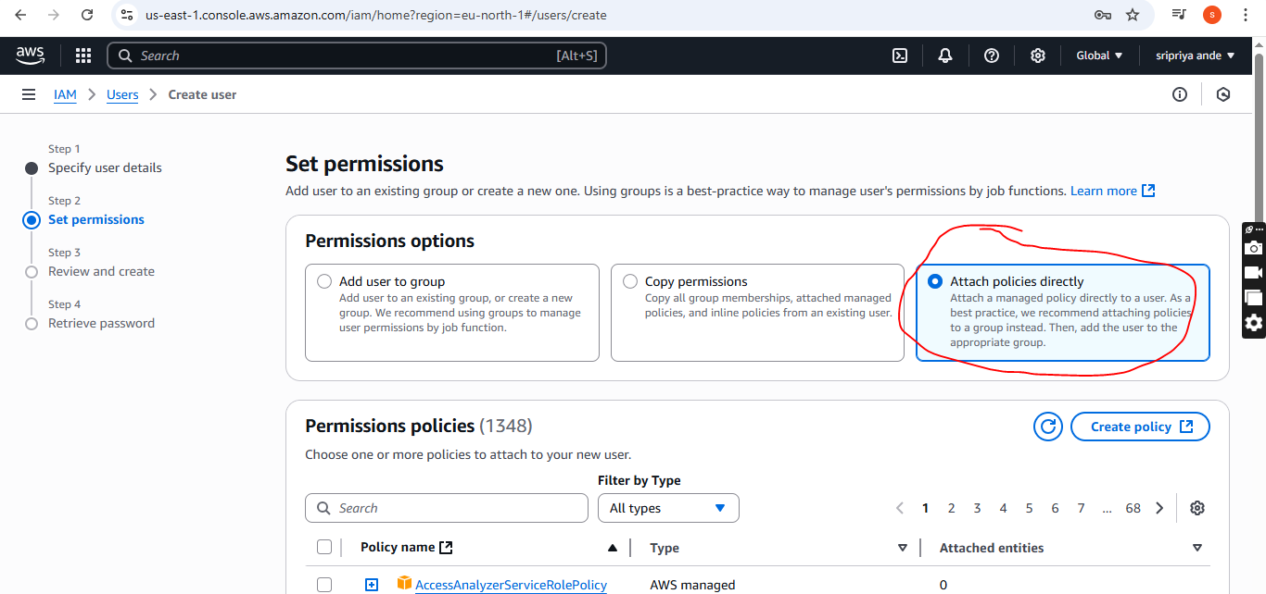

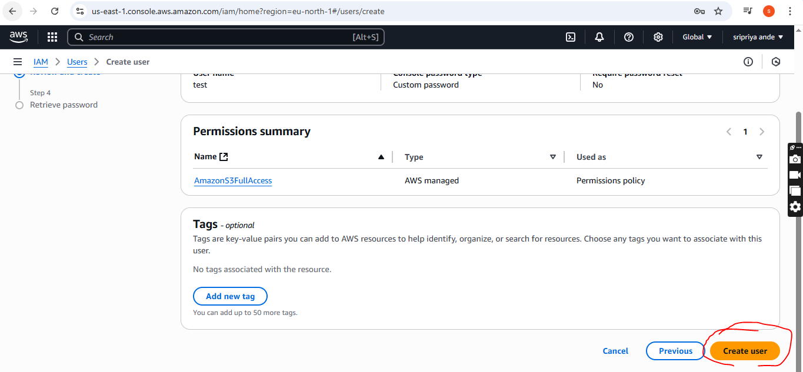

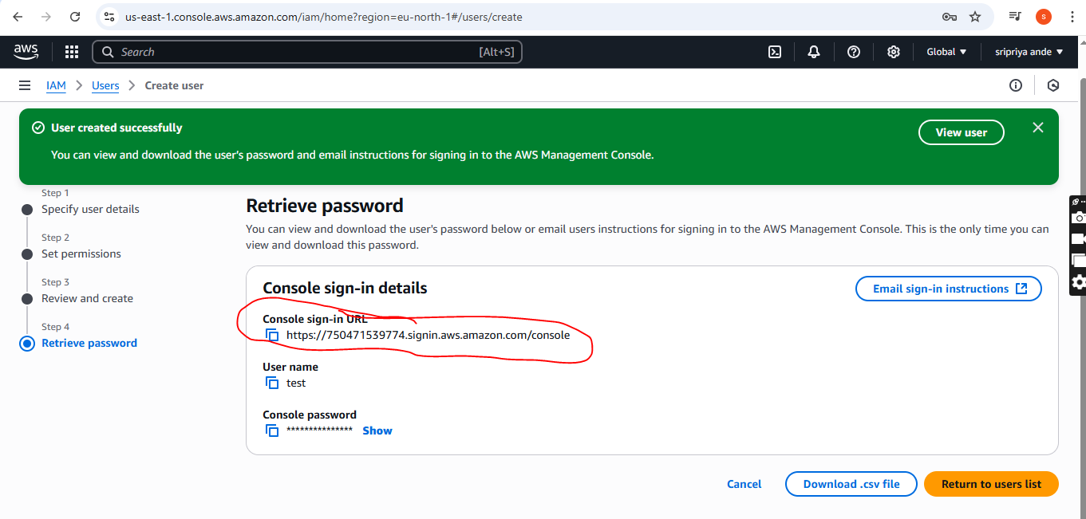

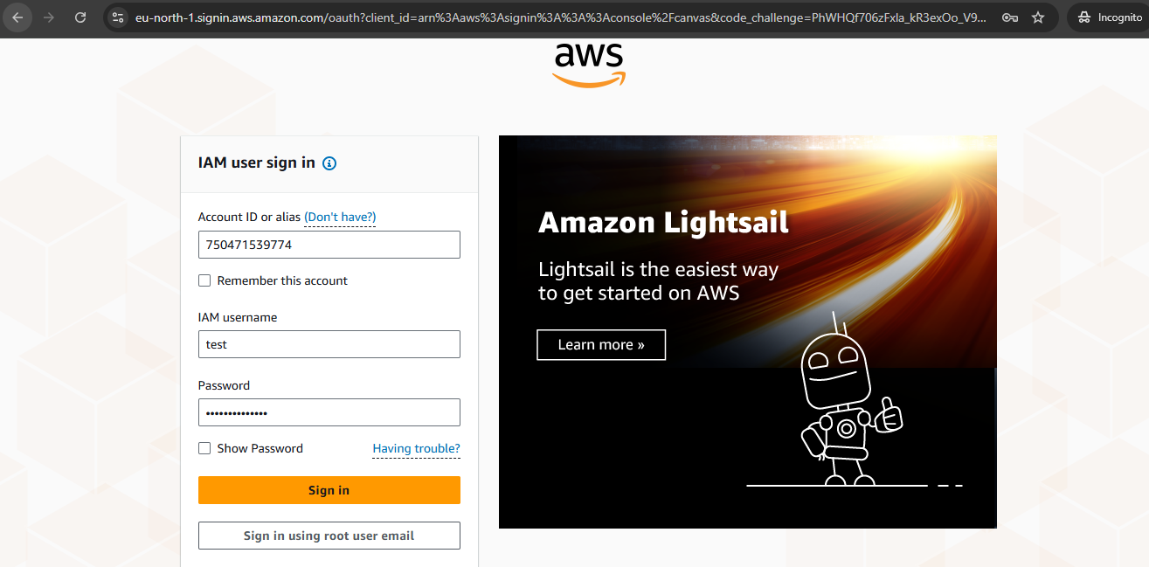

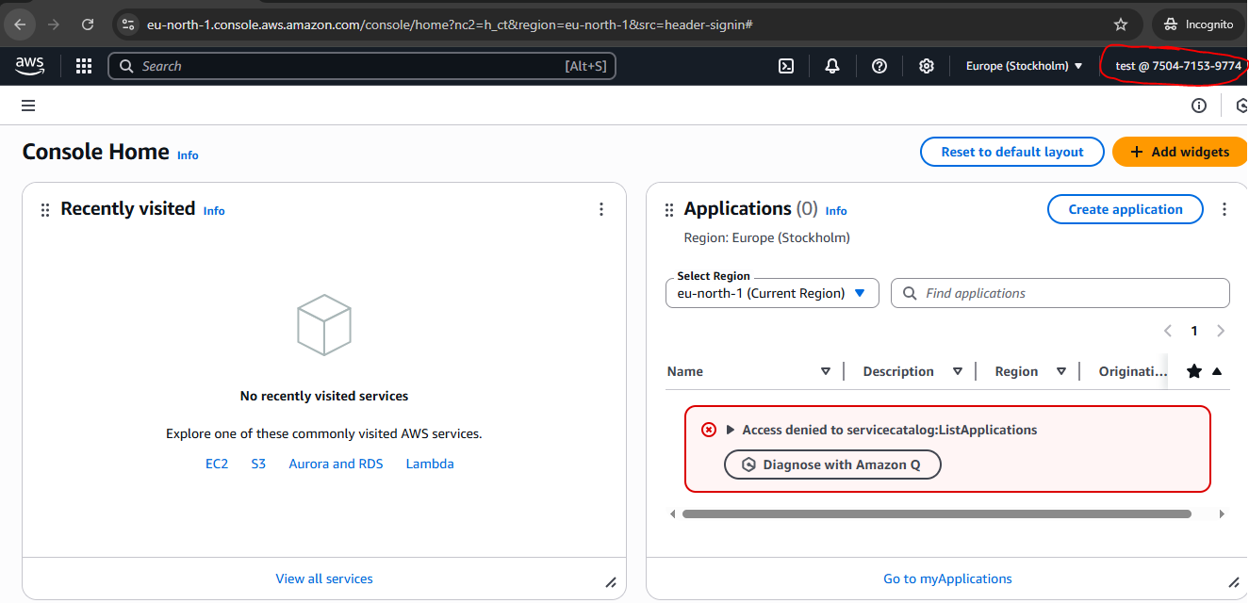

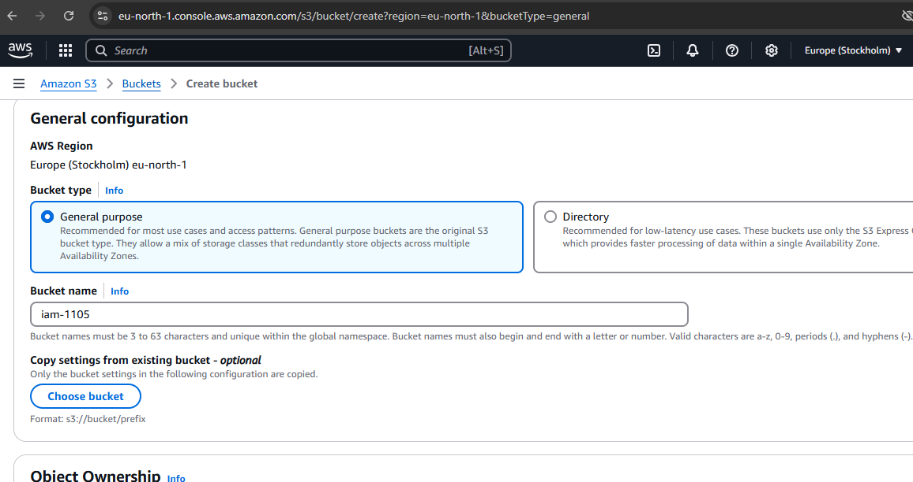

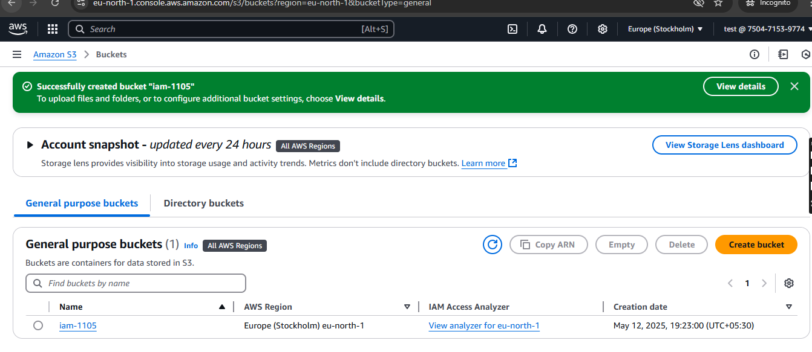

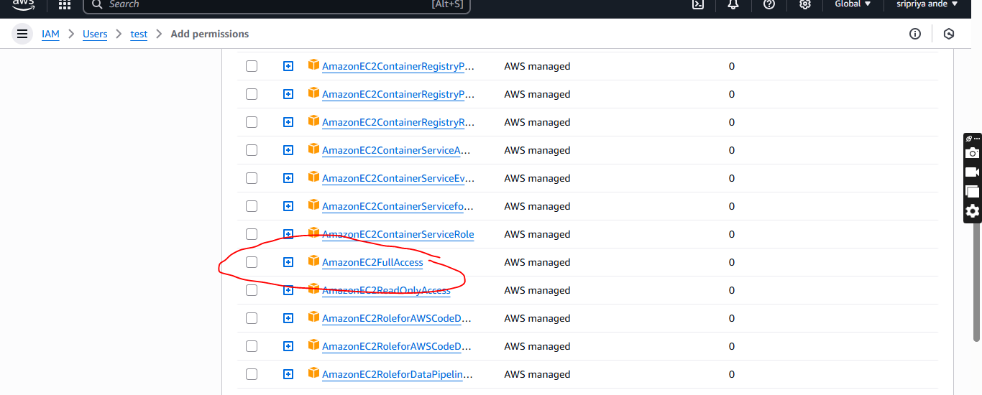

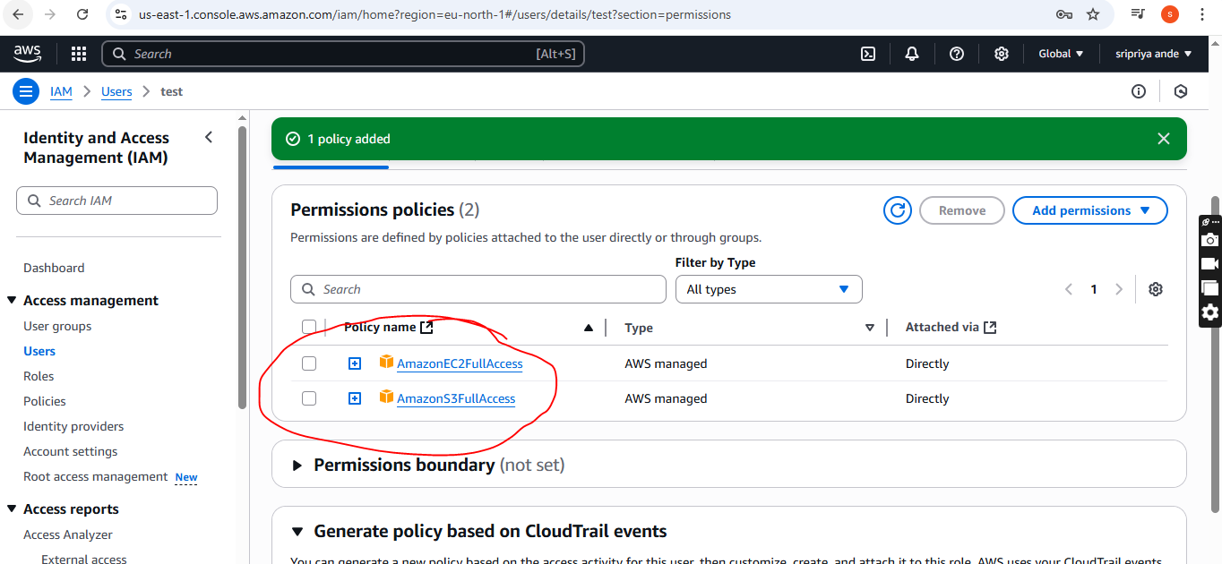

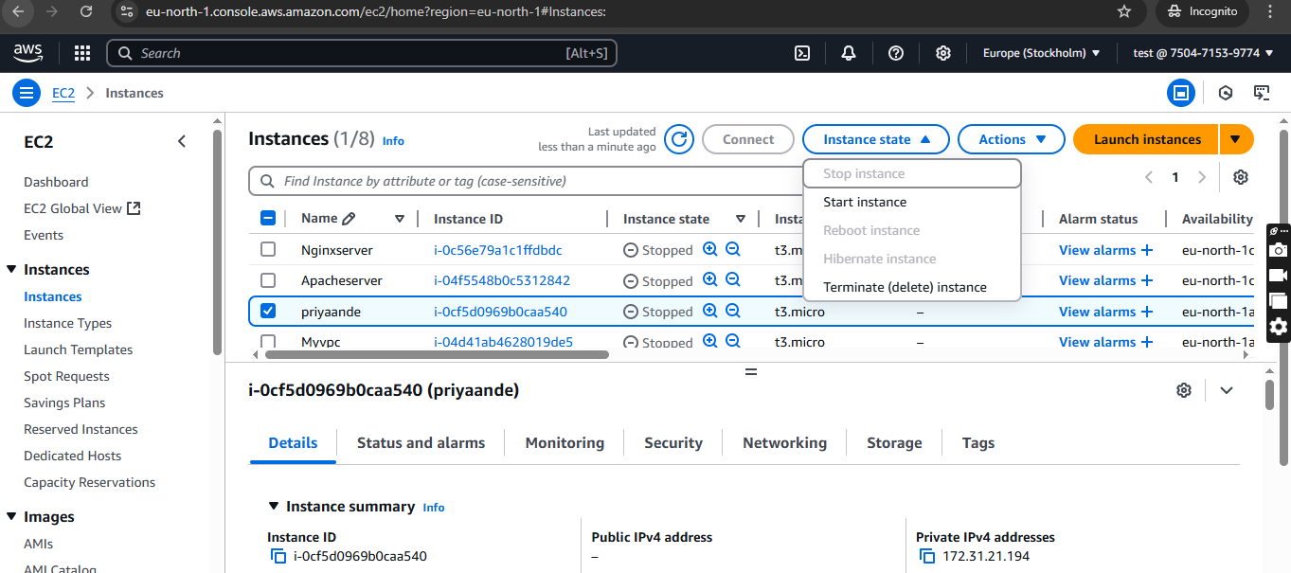

1. Create one Group in IAM and Assign Read access for ec2.

* Go to IAM in root user
* Go to user groups and click on create group
* Provide group name (eg:ops)
* **Add users to the group-test**
* Attach permission policies
* Then click on create group
* Go to user IAM
* Ec2 refresh you will get only read access

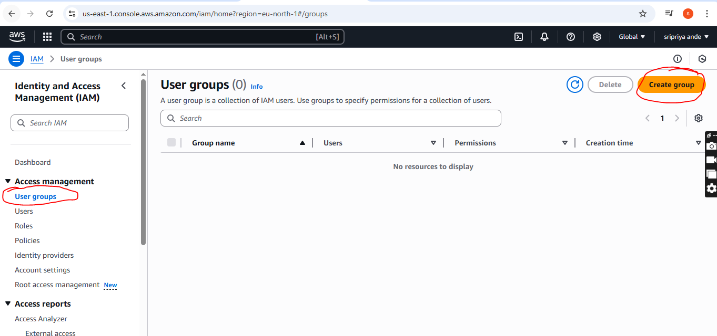

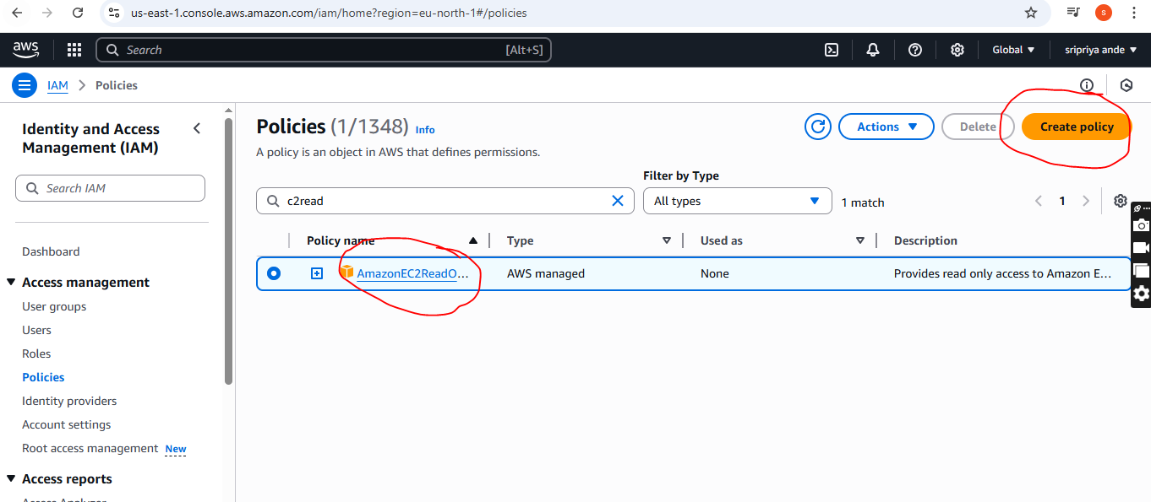

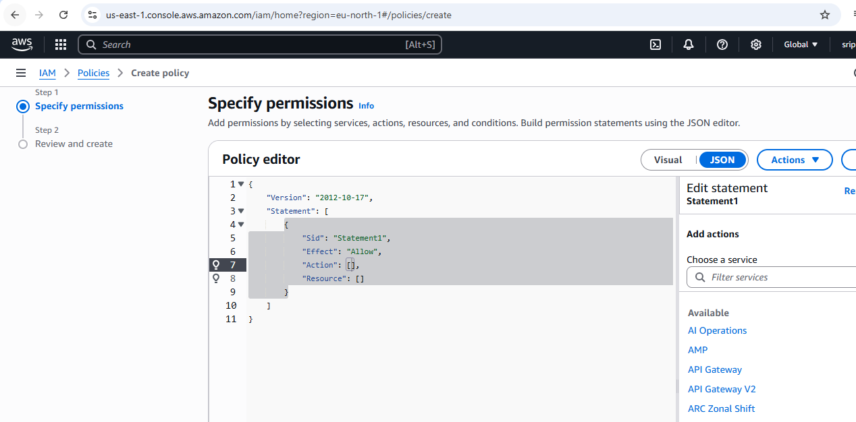

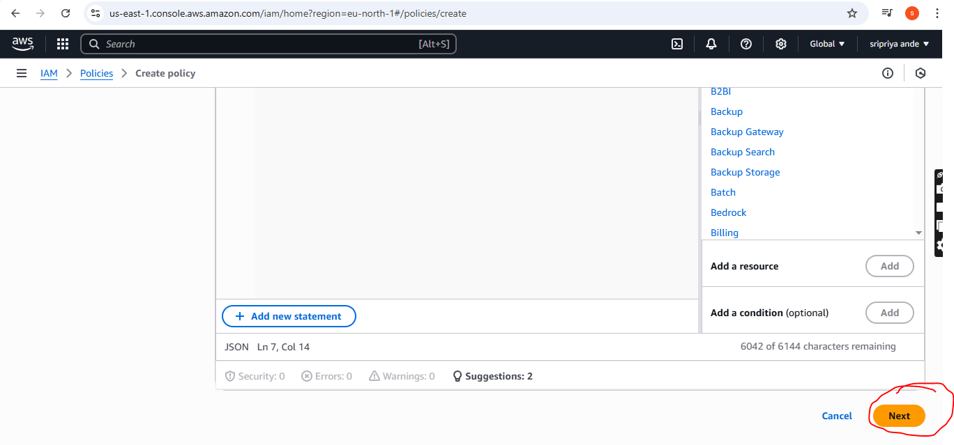

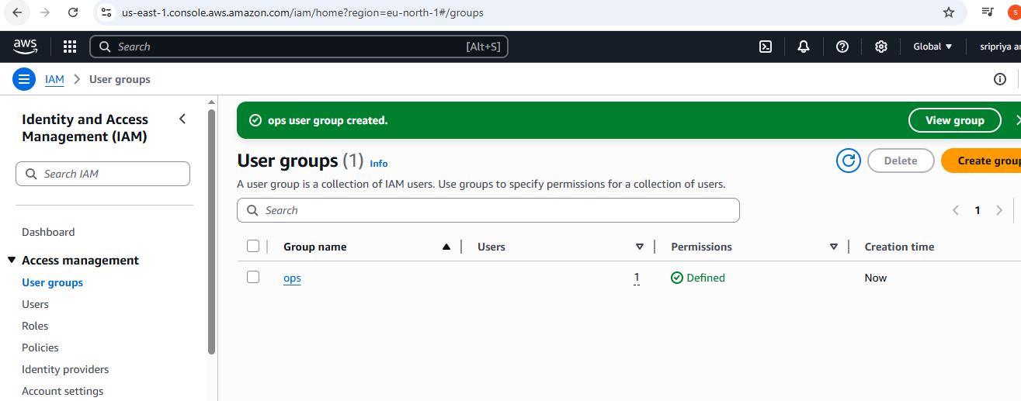

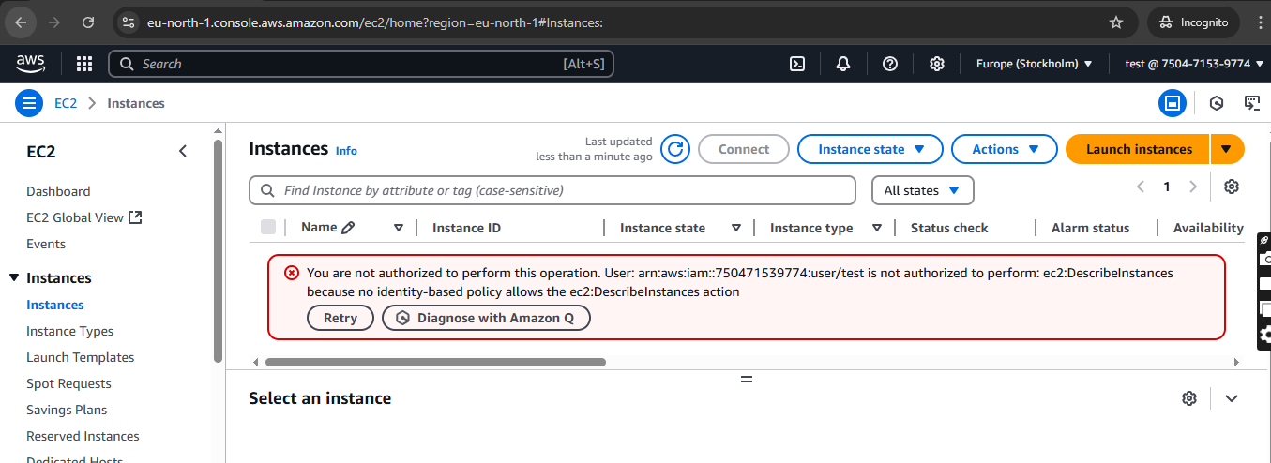

1. Create a new user with name Devops and add to the group created in task2.

* Go to users and click on create user
* Provide user name as Devops
* Tick check box and select I want to create an IAM user
* In Console password click on custom password
* Uncheck box
* Click next
* Permission option--->Add user to groupselect existing group--->create user

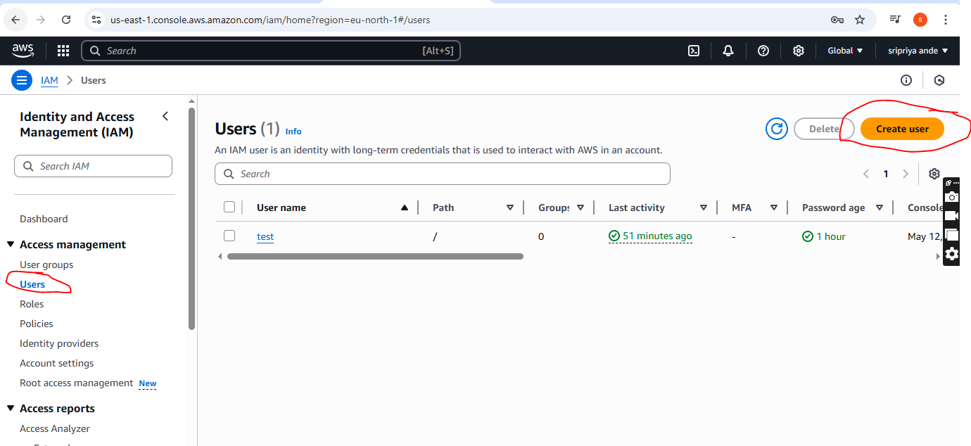

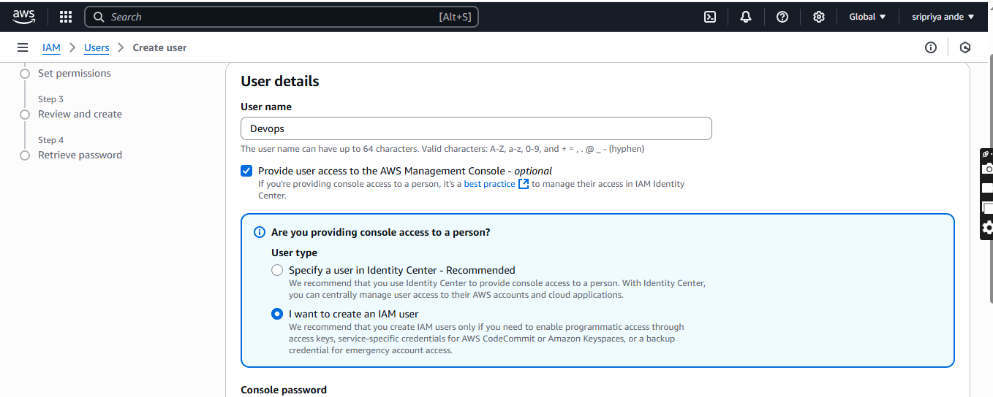

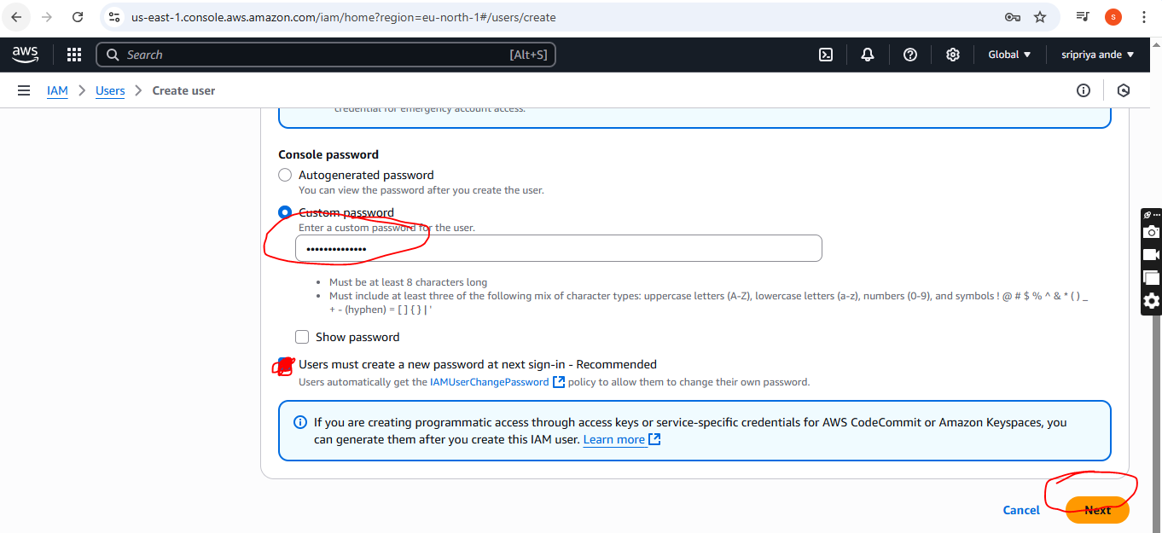

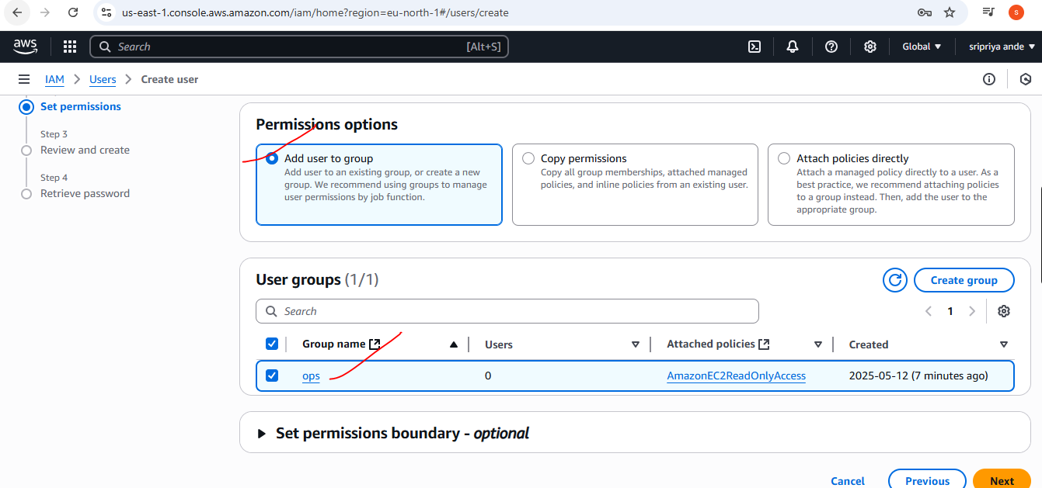

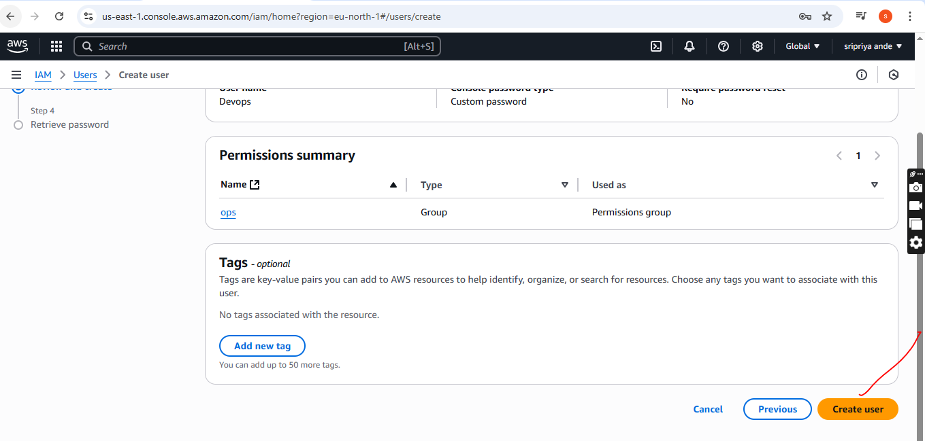

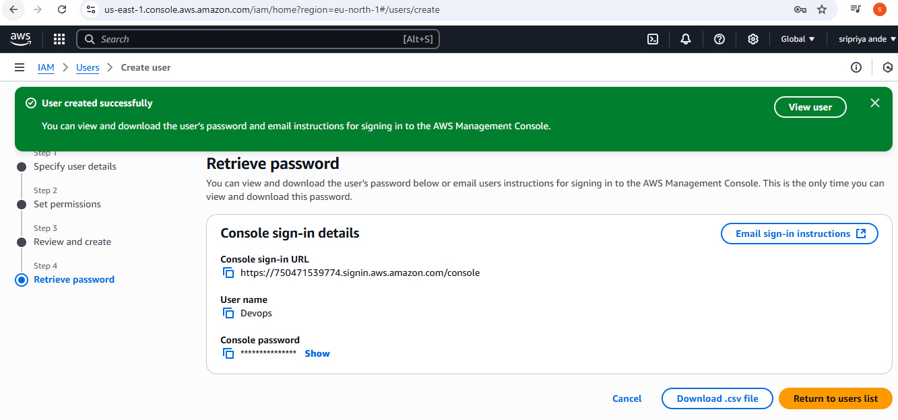

1. Write a bash script to create a IAM user with VPC full access.

* Go to git bash
* Enter aws configure
* Provide access key and security key
* $ aws sts get-caller-identity
* Creat one file vi createvpcuser.sh
* Paste this script in file

#!/bin/bash

# Set user name variable

USER_NAME="vpc-full-access-user"

echo "Creating IAM user: $USER_NAME"

# Create IAM user

aws iam create-user --user-name "$USER_NAME"

# Attach AmazonVPCFullAccess policy to user

aws iam attach-user-policy --user-name "$USER_NAME" --policy-arn

arn:aws:iam::aws:policy/AmazonVPCFullAccess

echo "User '$USER_NAME' created and AmazonVPCFullAccess policy attached."

Provide chomd +x <filename>

./filename

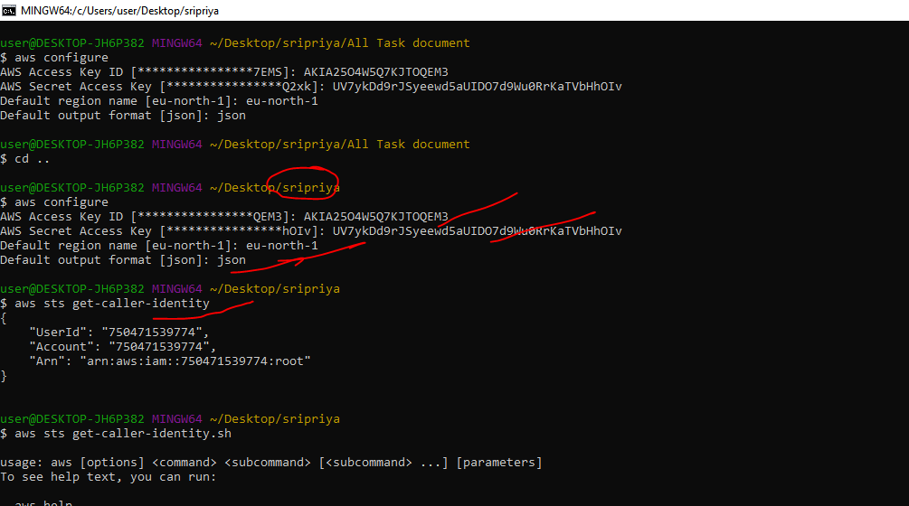

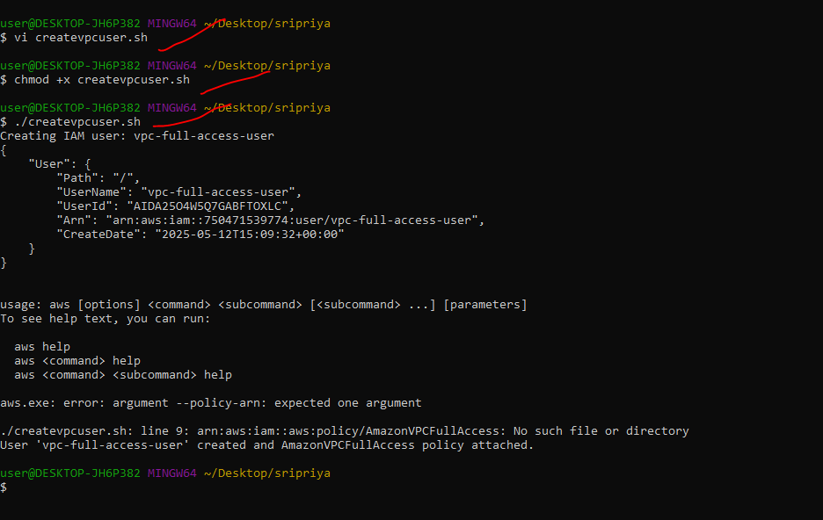

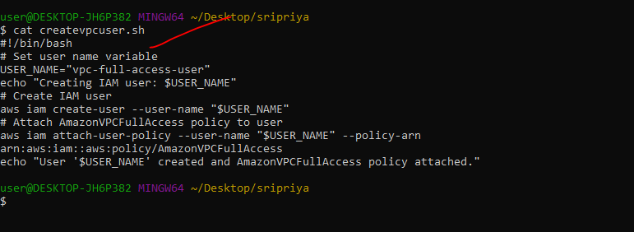

1. Create a IAM policy to access ec2 for a specific user in specific regions only.

* Go to IAM in root user
* Go to policies --->ec2

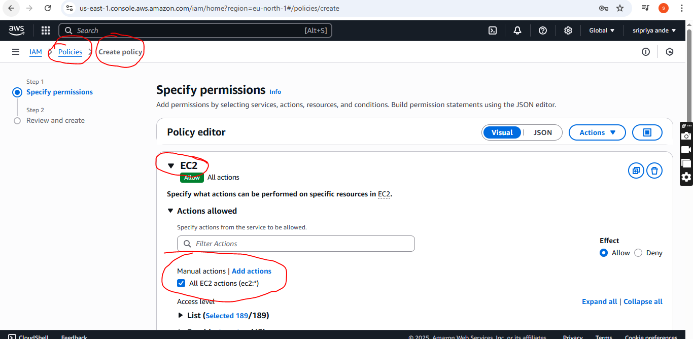

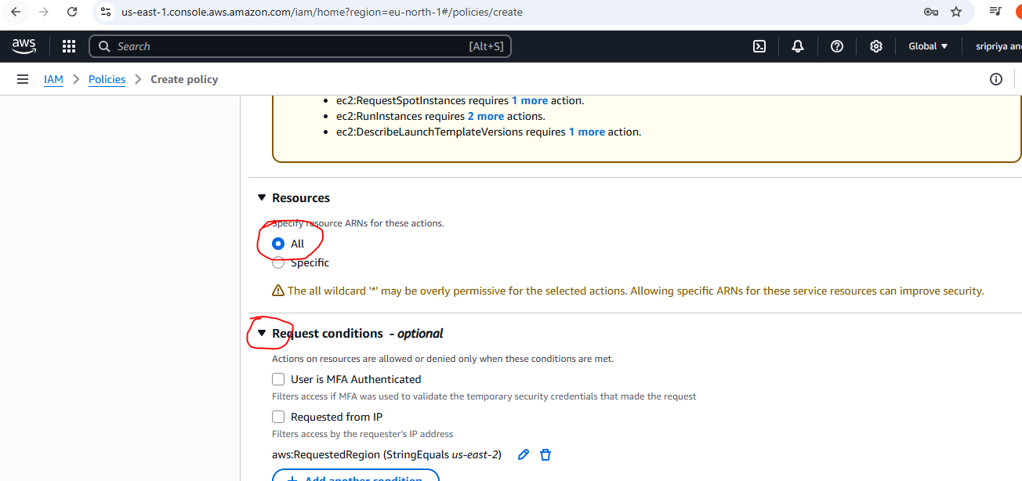

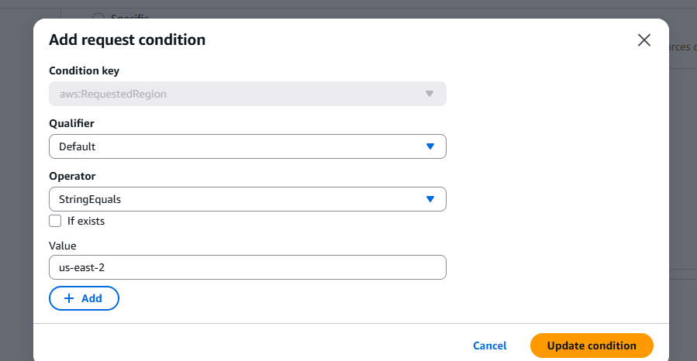

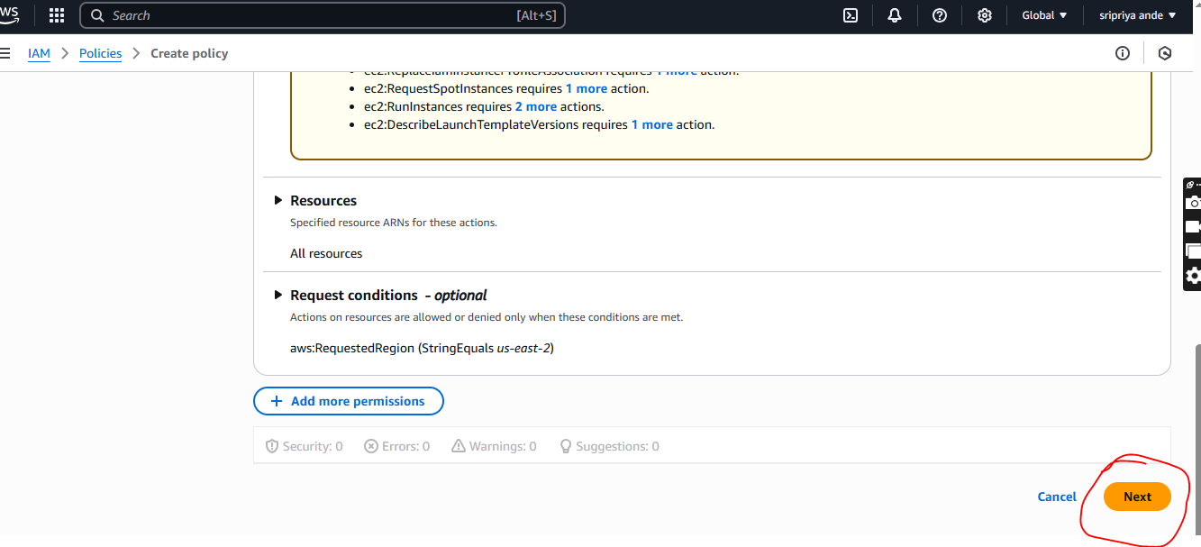

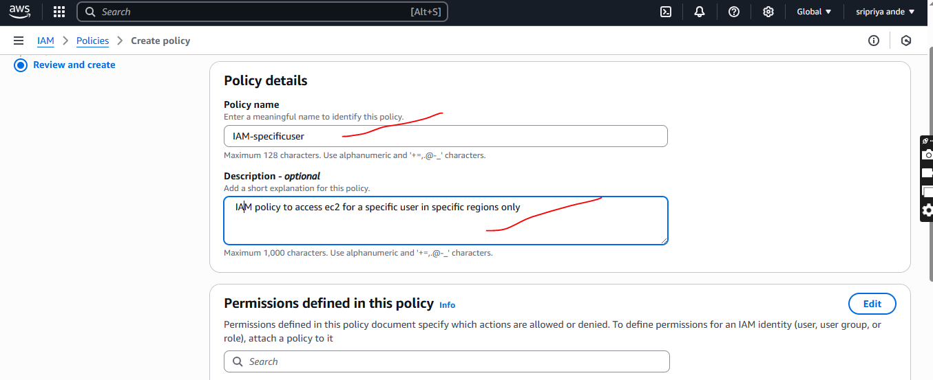

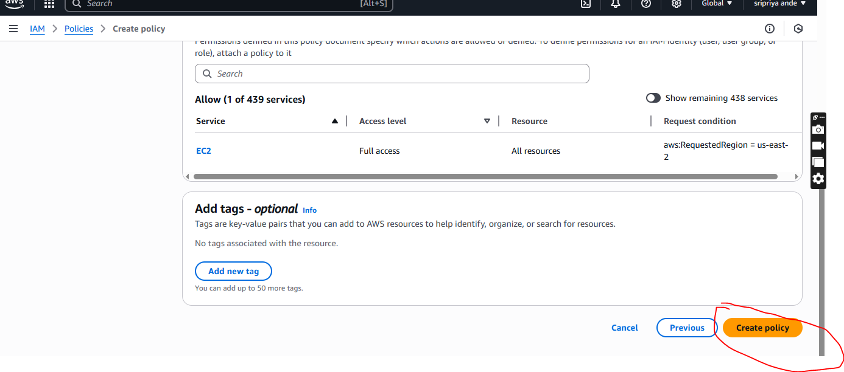

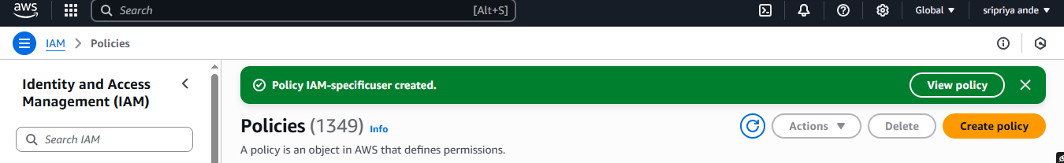

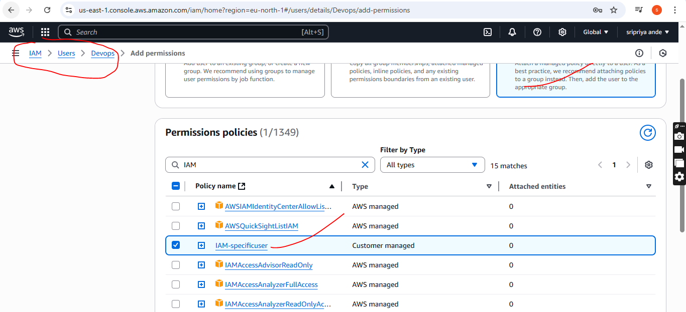

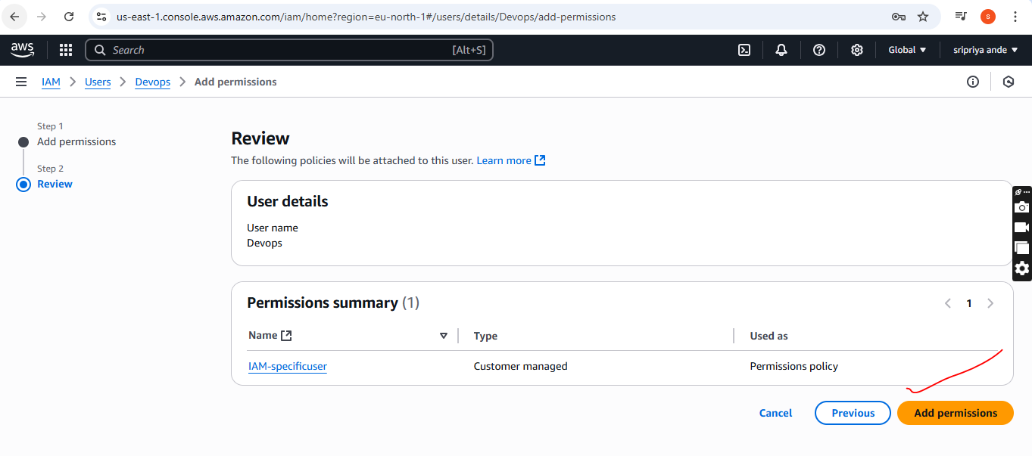

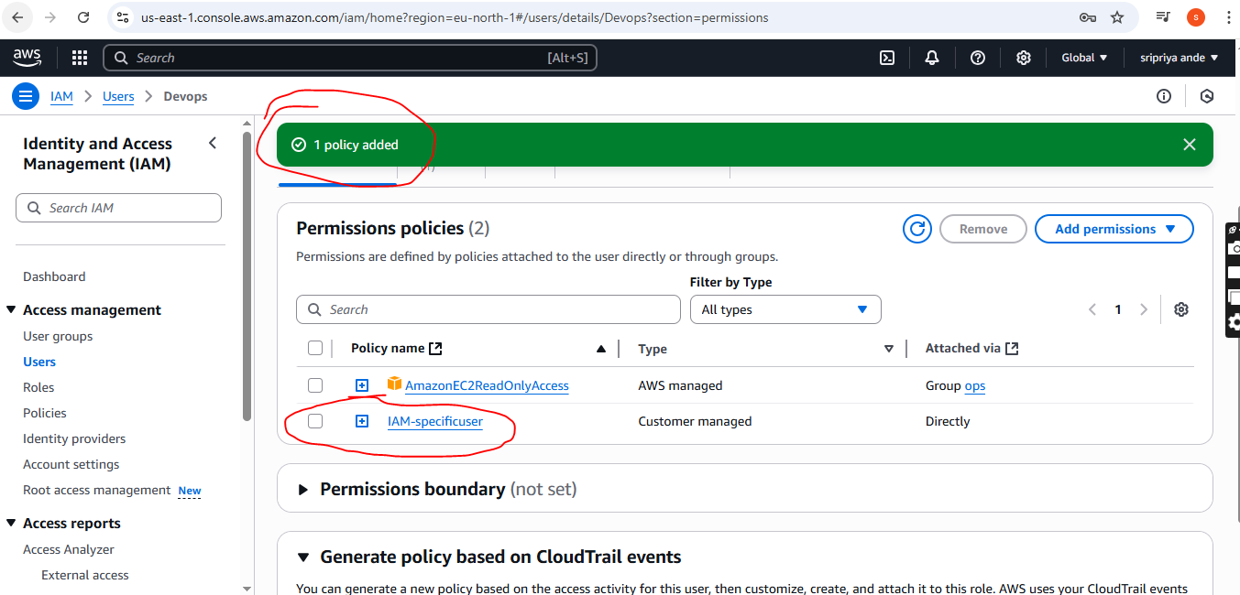

6) We have two accounts Account A and Account B, Account A user should access s3 bucket in Account B.

(Collaborate with team member and execute this.Mostly asked in every interview)

Create aws IAM in account A

And s3 bucket in account B

In aws IAM create user and and s3 bucket full access then provide persiion using below policy

**Account A(aws IAM inline policy )**

{

"Version": "2012-10-17",

"Statement": [

{

"Effect": "Allow",

"Action": [

"s3:GetObject",

"s3:ListBucket"

],

"Resource": [

"arn:aws:s3:::task-s3bucket-29",

"arn:aws:s3:::task-s3bucket-29/*"

]

}

]

}

In another account that is B create s3 bucket and and this policy in permission in account tab

**Account B(s3 bucket policy in another account)**

{

"Version": "2012-10-17",

"Statement": [

{

"Effect": "Allow",

"Principal": {

"AWS": "arn:aws:iam::750471539774:user/crossregion-IAM"

},

"Action": [

"s3:GetObject",

"s3:ListBucket"

],

"Resource": [

"arn:aws:s3:::task-s3bucket-29",

"arn:aws:s3:::task-s3bucket-29/*"

]

}

]

}

Then save all the changes

Go to git bash

In git bash

**aws configure --profile crossregion-IAM**

Provide access key and security key

After this

**aws s3 ls s3://task-s3bucket-29 --profile crossregion-IAM**

**Summary:**  To access s3 bucket from another we need s3 bucket user name

To connect IAM in s3 bucket the account user need ARN to connect

